# Test Design Techniques

# Homework

## Valid vs. Invalid Values

* Imagine you are a security guard at the airport. You have to define whether the hand luggage is allowed or not. Sort out the valid and invalid content or characteristic of the luggage by following the British Airline restrictions. Extra baggage is not allowed.

*You could check this [url](http://www.britishairways.com/en-gb/information/baggage-essentials/hand-baggage-allowances) for extra information about the restrictions. Check out the Packing restrictions at the bottom of the page.

VALID

INVALID

Wet wipes

Small scissors

Cough syrup 120ml

24kg bag

Umbrela

23*40*25 sized cabin bag

150 ml Perfume

23*30*25 sized personal bag

Thermometer with mercury

Laptop

Pepper spray

Tennis racket

## Test Design Techniques

* Below is the diagram of test design techniques – fill in the names of the different techniques and match them with a sentence form the box to the left. (See the example)

**Testing**

**(2)**

**(7)**

**(5)**

**(6)**

**(8)**

**(9)**

**(3)**

**(4)**

**(1)**

**(11)**

**(10)**

1. Tests are based on people's skills, knowledge, intuition and experience
2. One of the types is Walkthrough
3. Also called specification-based
4. Structure-based techniques
5. Involve running (executing)
6. Analyzing software “at rest”
7. Tests are derived systematically from what is known about the defect
8. What the system does?
9. Examining running software to see how it behaves under different stimuli
10. How the system does what it does?
11. Do not involve running (executing)
12. Static 🡪 K
13. Dynamic 🡪 E
14. Review 🡪 B
15. Static Analysis 🡪 F
16. Black-box 🡪 C
17. White-box 🡪 D
18. Experience-based 🡪 A
19. Defect-based 🡪 G
20. Dynamic analysis 🡪 I
21. Functional 🡪 H
22. Non-functional 🡪 J

* **1. Static - k**
* **2. Dynamic**
* **3.___________**
* **4.___________**
* **5.___________**
* **6.___________**
* **7.___________**
* **8.___________**
* **9.___________**
* **10.__________**
* **11.__________**
* **1. Static - k**
* **2. Dynamic**
* **3.___________**
* **4.___________**
* **5.___________**
* **6.___________**
* **7.___________**
* **8.___________**
* **9.___________**
* **10.__________**
* **11.__________**
* **1. Static - k**
* **2. Dynamic**
* **3.___________**
* **4.___________**
* **5.___________**
* **6.___________**
* **7.___________**
* **8.___________**
* **9.___________**
* **10.__________**
* **11.__________**

\

## Boundary Value Analysis, Equivalence Partitioning & Use Case

* Go to <http://demos.telerik.com/aspnet-ajax/imageeditor/examples/imageupload/defaultcs.aspx?product=asyncupload>

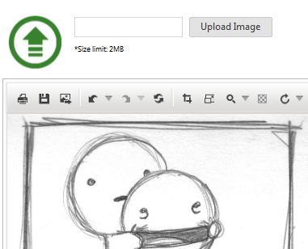

|  |  |
| --- | --- |
| 1. | Upload an image between 0.1 – 2 MB with various extensions (.jpeg, .png, .gif, .bmp, .raw) |
| 2. | Upload an EMPTY image with various extensions (.jpeg, .png, .gif, .bmp, .raw) |
| 3. | Upload an image more than 2 MB with various extensions (.jpeg, .png, .gif, .bmp, .raw) |
| 4. | Upload an invalid file (i.e. .txt, .docx, .avi) between 0.1 – 2 MB |
| 5. | Upload an invalid file (i.e. .txt, .docx, .avi) of more than 2 MB |
| 6. | Upload an image with changed extension (i.e. from .jpeg to .txt) |
| 7. | Upload an invalid file (i.e. .txt, .docx, .avi) with changed extention (i.e. to (.jpeg, .png, .gif, .bmp) |

* Go to <http://demos.telerik.com/aspnet-ajax/input/examples/common/datagrid/defaultcs.aspx>
* 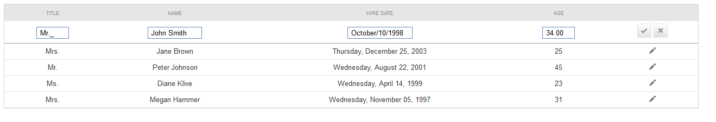

1. Think of appropriate test cases to test the controls and write them down in a table
2. If you find any bugs, please feel free to report them in a MS Word document

|  |  |
| --- | --- |
| 1. | Try to submit a row with a null field (try to do it with each of the cells being null, while the others are valid) |
| 2. | Submit a row with valid data |
| 3. | Submit a row with valid data with ***Age*** : 0 | 1 | 120 | 121 |
| 4. | Submit a row with valid data with ***Hire Date*** : [MIN DATE] – 1 | [MIN DATE] | [MAX DATE] | [MAX DATE] + 1 |
| 5. | Submit a row with valid data with ***Name*** with : Different alphabets (i.e. Latin, Cyrillic, Arabic) | Different length ( 1 | 1 000 | 1 000 000) | Numbers |
| 6. | Submit a row with valid data with ***Title*** : Dr. | Mrs | Mr | Ms | Invalid title (i.e. Prof.) | Number |

* Download the project MonopolyGame.zip. Run the project following this steps:

1. Unzip the project
2. Run the solution
3. Run the Web Application *//CTRL+F5* ☺

Navigating through the tabs you will find your tasks. Make an archive with your solutions.

**Form test cases**

***NOTE: The form keeps reloading after each input change, so I was not able to do automated tests***

|  |  |
| --- | --- |
| 1. | Try to submit the form with valid data |
| 3. | Submit a row with valid data with ***Player’s count*** : 1 | 2 | 4 | 6 | 7 |
| 4. | Submit a row with valid data with ***Money for a player*** : 1199.99 | 1200.00 | 1200.01 | 1500.00 | 1500.01 |
| 5. | Submit a row with valid data with ***Names of players*** with : Different alphabets (i.e. Latin, Cyrillic, Arabic) | Different length ( 1 | 1 000 | 1 000 000) | Numbers |

***USE CASES (it would have taken me ages to do that in diagrams, so I did it as an ordered list with options and sub-options)***

1. Step on an unowned land
   1. Buy it if you have the money and want to do it
   2. Wait for your turn
2. Step on a land owned by someone else
   1. Pay rent if you have the money
   2. Declare bankruptcy
3. Step on your land
   1. Build a house/hotel if you can, have the money and want to do it
   2. Do nothing
4. Step on “Go to Jail”
   1. If you have a “Free from Jail Card” use it on you next turn
   2. Try to throw doubles
   3. Pay the release money of you have them
5. Pass through “Go”
   1. Collect 200
6. Step on Chance field
   1. “GoTo” cards 🡪 move as per direction and check the tile for more options
   2. “Receive money” cards 🡪 get the money from the bank
   3. “Give money” cards
      1. Pay the money if you can
      2. Declare bankruptcy
7. Step on Community field“
   1. Receive money” cards 🡪 get the money from the bank
   2. “Give money” cards
      1. Pay the money if you can
      2. Declare bankruptcy
8. Step on a “Pay tax” tiles
   1. Pay the money if you can
   2. Declare bankruptcy